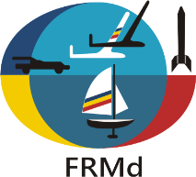
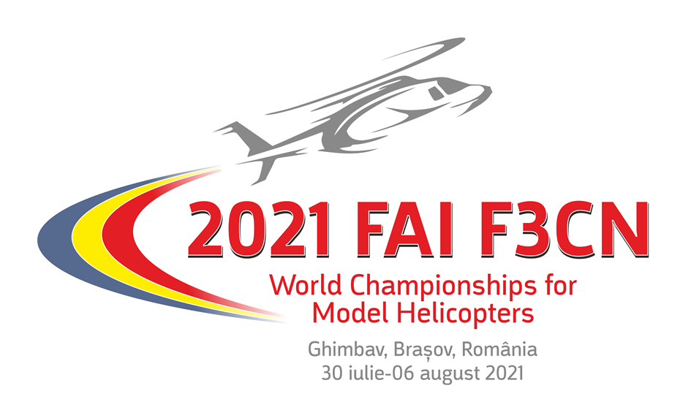

PRELIMINARY ENTRY FORM

NATIONAL AEROCLUB / FEDERATION OF ________________________________________
CORESPONDANCE ADDRESS _____________________________________________________
_____________________________________________________
____________________________________________________
EMAIL_____________________________
PHONE_____________________________

NATIONAL TEAM F3C - Reigning F3C World Champion_____________
- F3C Team Manager___________
- F3C Senior Competitors__________
- F3C Junior Competitors__________
- F3C Female Competitors__________
- F3C Callers__________
- F3C Mechanics_______
- F3C Helpers_________
- F3C Supporters_______
NATIONAL TEAM F3N - Reigning F3N World Champion_____________
- F3N Team Manager___________
- F3N Senior Competitors__________
- F3N Junior Competitors__________
- F3N Female Competitors__________
- F3N Callers__________
- F3N Mechanics_______
- F3N Helpers_________
- F3N Supporters_______
TOTAL PERSONS______________

Press representatives_________
Persons in hotel_____________

Fill in and return to: FEDERATIA ROMANA DE MODELISM
CALEA PISCULUI, Nr.10, SALA POLIVALENTA, Camera II-15
Sector 4, BUCURESTI, ROMANIA
TEL:+40-31-805 7471
E-mail: ioanaeu822@gmail.com

PLEASE RETURN BY E-MAIL UNTIL the April 30th, 2021.

SIGNATURE & STAMP OF NAC/FEDERATION

_________________________________________
DATE____________________________

